PRESS KIT

A Child’s Question to Kindness

Book Information
Title: A Child’s Question to Kindness
Author: Tanzim Redwan (16)
Genre: Dystopian / Philosophical Fiction
Length: ~90 pages
Language: English
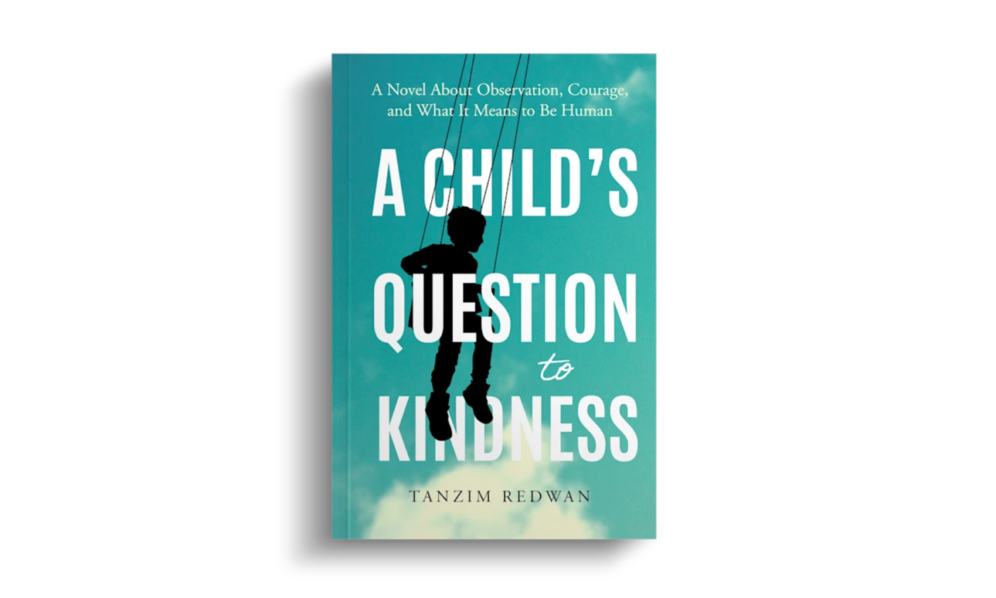

Short Synopsis
In a world where kindness is regulated, monitored, and weaponized, one child dares to ask a dangerous question:
What if kindness isn’t what we think it is?
A Child’s Question to Kindness is a haunting philosophical narrative that explores power, control, and morality through the eyes of a child navigating a system designed to define humanity itself.

Full Synopsis
Set in a dystopian society where emotional expression is subtly controlled, the story follows a young protagonist who begins to question the very foundation of kindness—a concept that the system claims to uphold.
As the child encounters contradictions between what is taught and what is experienced, the narrative unfolds into a deeper exploration of truth, freedom, and the cost of questioning authority.
Blending philosophical depth with emotional storytelling, the book challenges readers to rethink whether kindness is inherently good—or something that can be shaped, manipulated, and enforced.
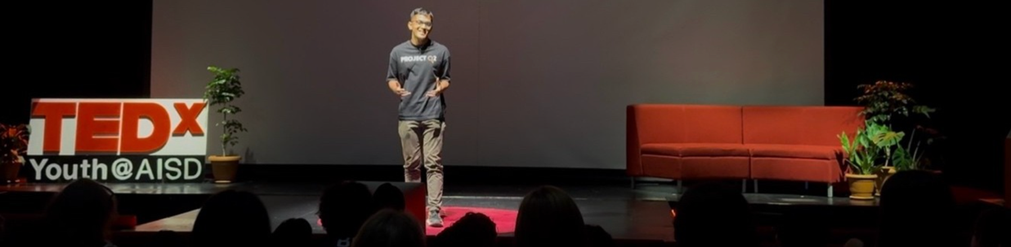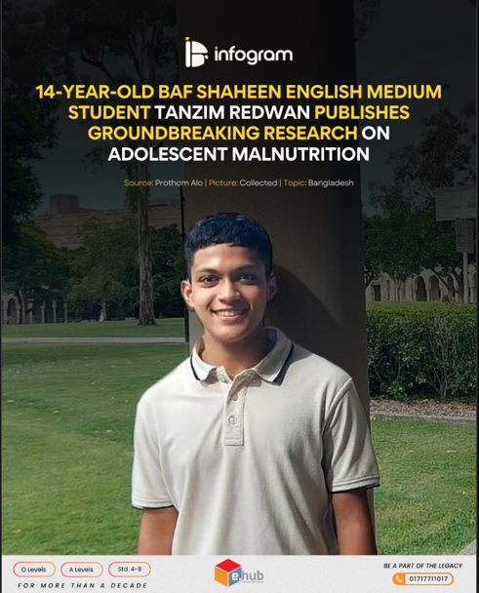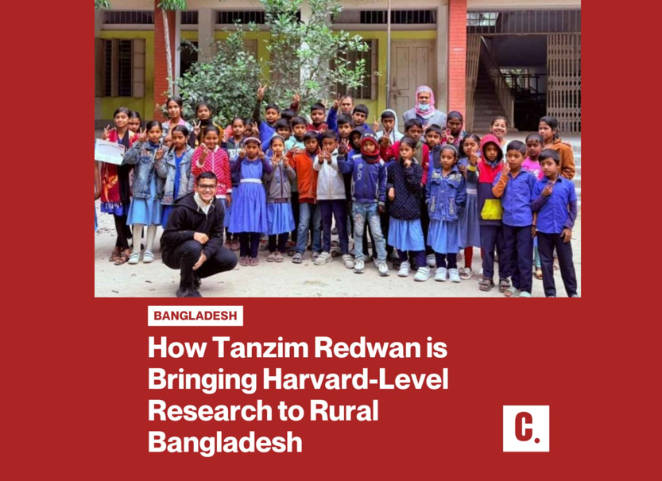

About the Author
Tanzim Redwan is a 16-year-old Bangladeshi student researcher, youth entrepreneur, and author working at the intersection of science, education, and storytelling.
He is the Founder of Project Q2, a youth-led initiative aimed at democratizing research for high school students, reaching over 2,000 students across multiple countries. His work focuses on making research and intellectual exploration accessible beyond elite institutions.
Tanzim is a published researcher with a Springer Q2 journal publication in Discover Sustainability, focusing on adolescent malnutrition in Bangladesh using advanced decision-making models.
He has represented his work internationally, including presenting at IEEE conferences in Singapore, and has been recognized as a Top 30 Finalist for the International Children’s Peace Prize.
In addition to his academic work, Tanzim is a national-level public speaker and has been featured in major Bangladeshi media outlets for his efforts in education and research advocacy.
A Child’s Question to Kindness marks his debut in fiction—bringing together his philosophical curiosity and real-world experiences into a compelling narrative.

Achievements & Recognition
- Springer Q2 Publication (Discover Sustainability)
- IEEE Conference Presenter (Singapore)
- Top 30 Finalist — International Children’s Peace Prize
- Founder, Project Q2 (2000+ students reached globally)
- Founder, MAANUSH (education initiative for underprivileged youth)
- National Public Speaking Champion
- Multiple national media features (Bangladesh)

Key Themes
- The nature of kindness: inherent vs constructed
- Control of morality in structured societies
- Youth questioning authority
- Education and intellectual freedom
- Ethical dilemmas in modern systems
- Social inequality and philosophical resistance

Suggested Media Angles
- “The 16-year-old Bangladeshi author redefining kindness through dystopian fiction”
- “From research to storytelling: how a young scientist explores morality”
- “Why today’s youth are questioning the systems that define ‘good’ and ‘bad’”
- “A rising voice from Bangladesh blending science, philosophy, and fiction”

Why This Book Matters
At a time when systems increasingly shape how individuals think, behave, and even empathize, A Child’s Question to Kindness offers a timely reflection on the boundaries between genuine humanity and imposed values.
It is not just a story—it is a question directed at the reader:
Are we truly kind, or have we simply learned how to appear so?

Contact & Links
Author: Tanzim Redwan
Email: tanzimredwan18@gmail.com
LinkedIn: https://www.linkedin.com/in/tanzimredwan2434/
Book Availability:
Amazon: (Coming Soon)
Rokomari: https://www.rokomari.com/book/547635/a-child-s-question-to-kindness

Available Upon Request
- Advance Review Copy (PDF / EPUB)
- Author Interviews
- Guest Articles / Op-eds
- Speaking Engagements

Media Assets for Public Use
(Available Only in DOCX Format)
